Date: 09-Sep-2025

Executive Summary

- Overall booth outcomes (Form20-coded):
- INDIA 38.7%,
- NDA 49.9%,
- OT 11.4%
- (n=77,292).
- Overall deletion composition:
- Hindus 74.4%,
- Muslims 15.2%,
- Unknown 8.9%.
- Muslim share of deletions vs NDA win share (bin-level): r≈-0.52.
- Trend by deletions-per-booth: as we move from Low (1–99) → Mid (100–249) → High (≥250) bins:
- Muslim share of deletions rises modestly.
- Hindu share of deletions declines slightly.
- Unknown share tapers.
- Per-booth levels: Hindu and Muslim deletions per booth both increase with the higher deletion bins (by definition of the bins), but the composition shift (Muslim share up, Hindu share down) is the key pattern.

Key Charts
Win share by deletion bin:
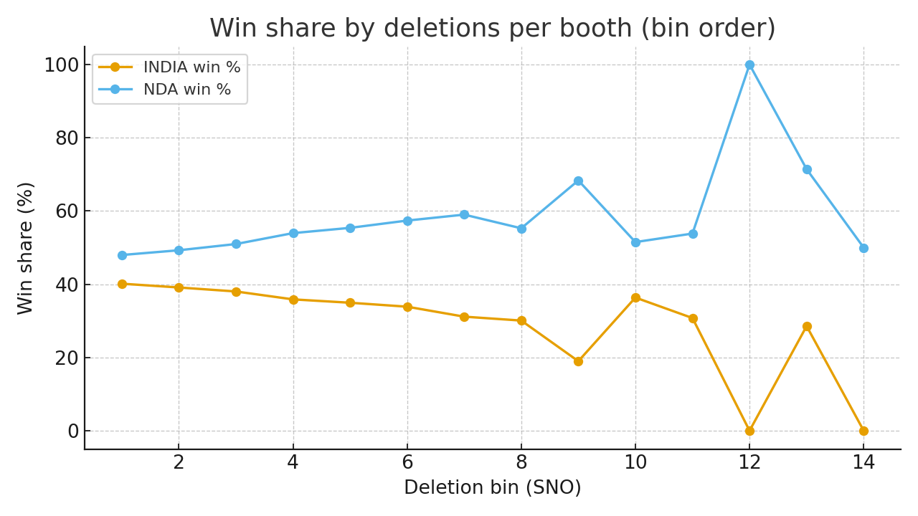
Religion composition of deletions by bin:
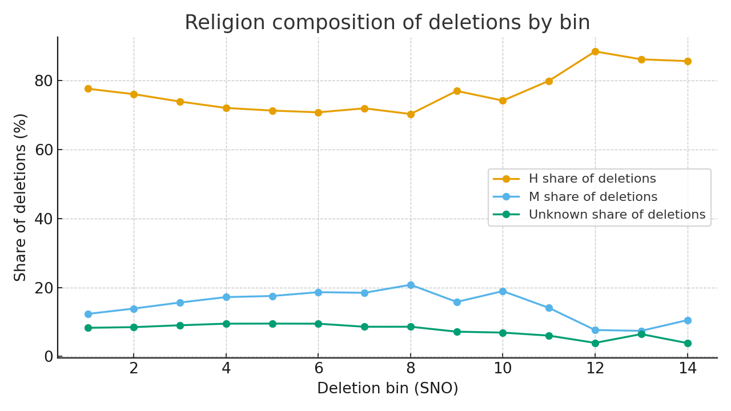
Muslim-deletion share vs NDA win share (scatter):
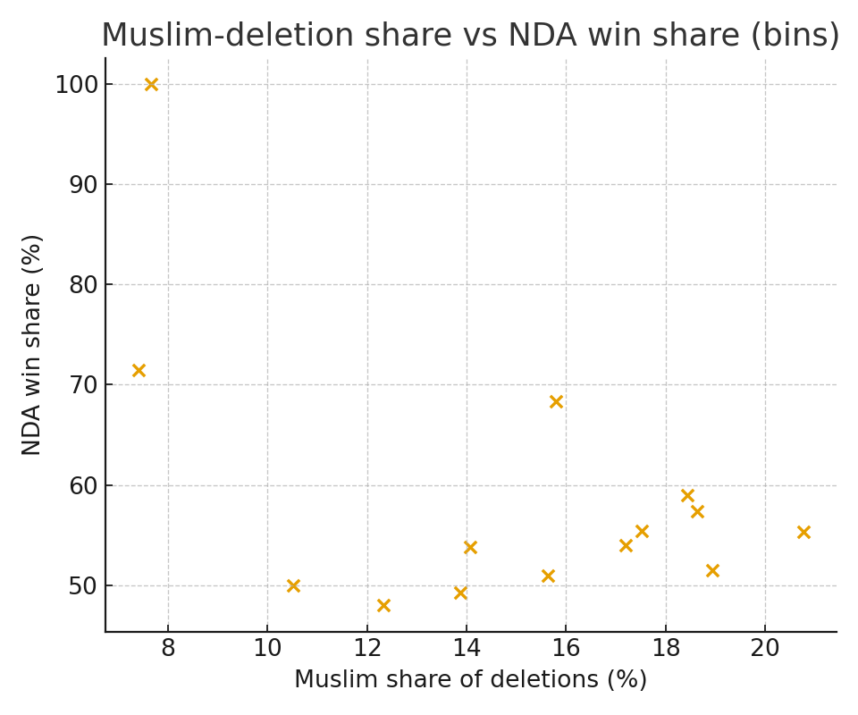
Booths counted by deletion bin (Form20):
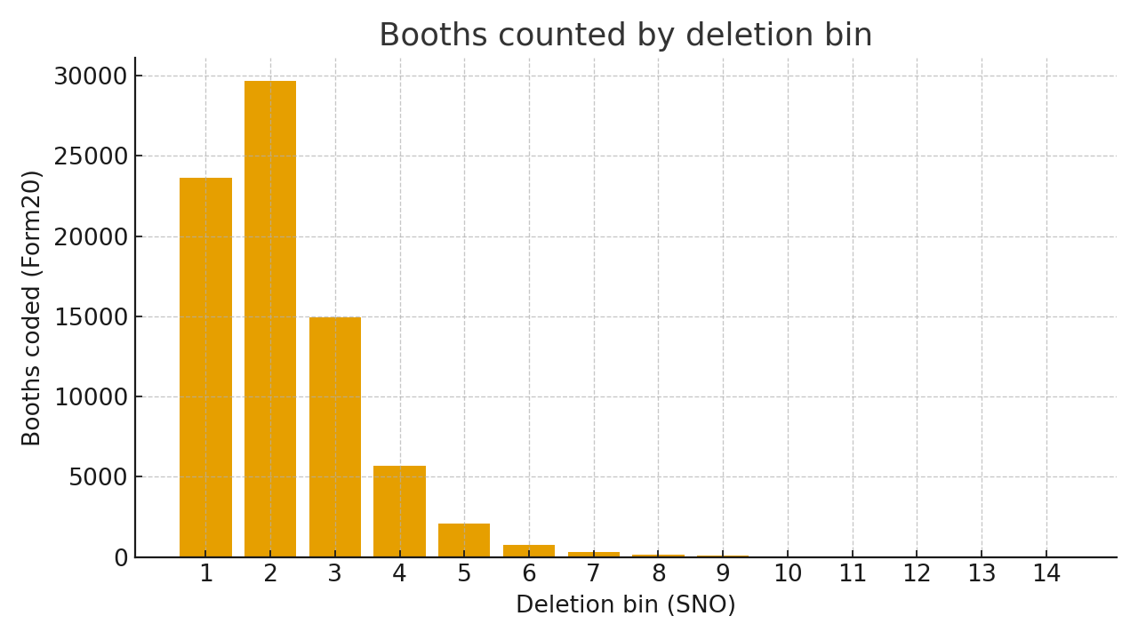

Bucket Summary (Low/Mid/High)
Bucket | Booths (Form20) | INDIA win % | NDA win % | Del/Booth | H % of del | M % of del | UK % of del
Low (1–99) | 53,265 | 39.6% | 48.7% | 53.9 | 76.4% | 13.5% | 8.4%
Mid (100–249) | 22,714 | 37.2% | 52.1% | 142.3 | 73.0% | 16.4% | 9.2%
High (≥250) | 1,313 | 31.8% | 58.3% | 312.3 | 72.1% | 18.3% | 8.7%
Notes: Extreme deletion bins comprise few booths; interpret with caution. Religion figures reflect deletion composition, not population shares.

